OpenMPI Asignment
CS430 – Parallel Programming
Md Syed Ahamad
Roll No.: 1301030
Q1. Tested with 4mb providing 2 processess, average speed turned out to be nearly 1.6 Gbps. It is also be tested with copying big chunk of memory.

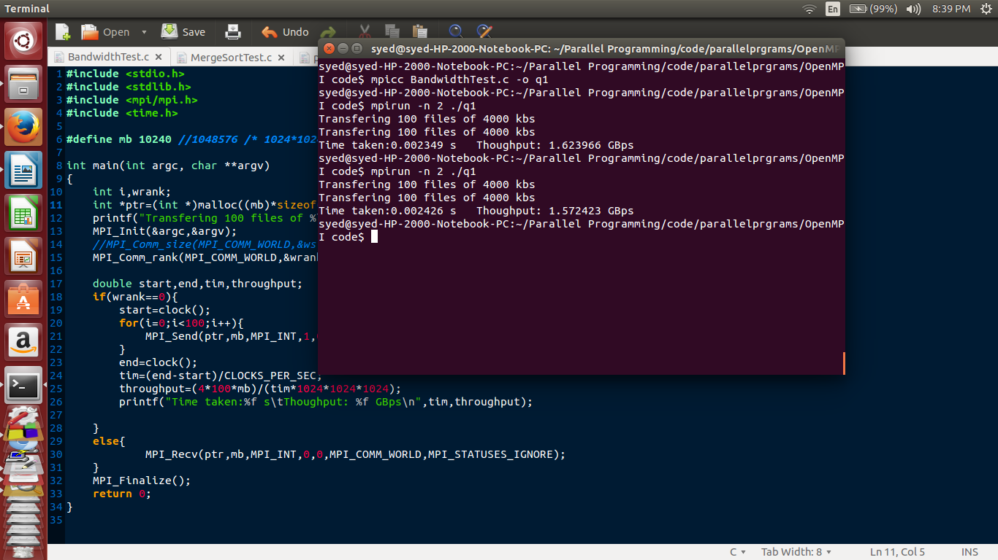

Q2. Providing 16 threads, point to point and collective broadcast is tested by transfering 4kb of data. Thier respective time taken are shown in the screenshot.

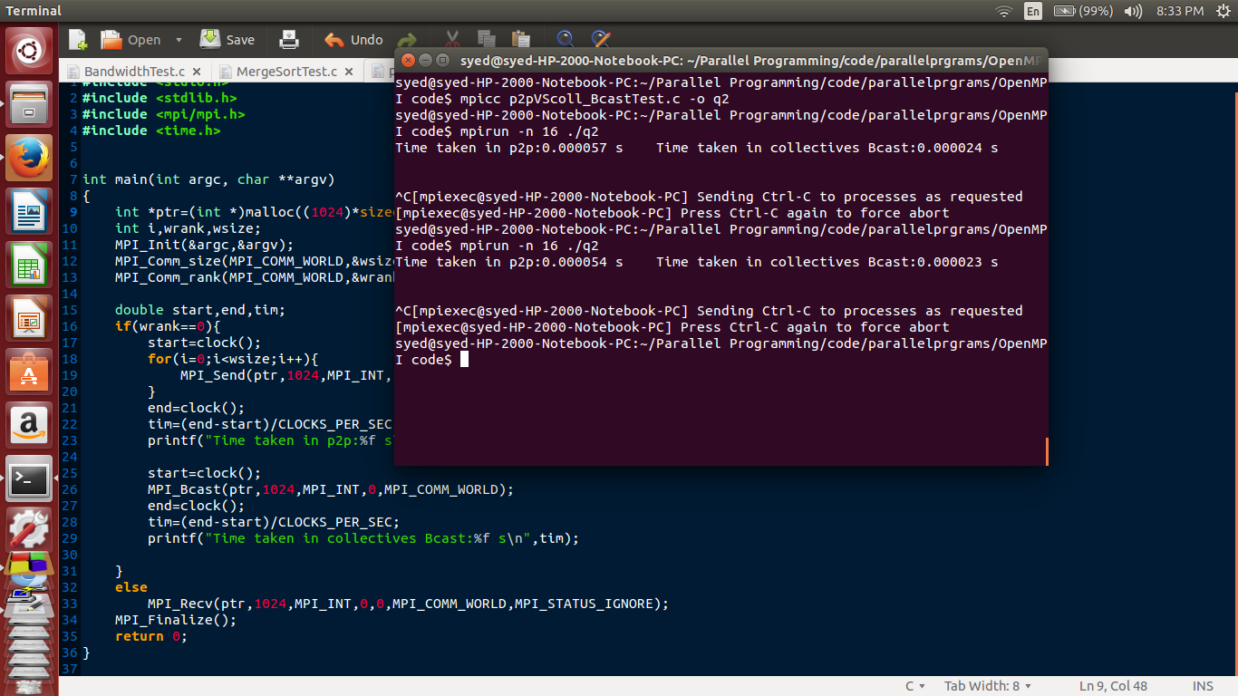
Q3. Merge sorting is tested with 100000 random numbers with 16 processes. Time taken is given in the screenshot.

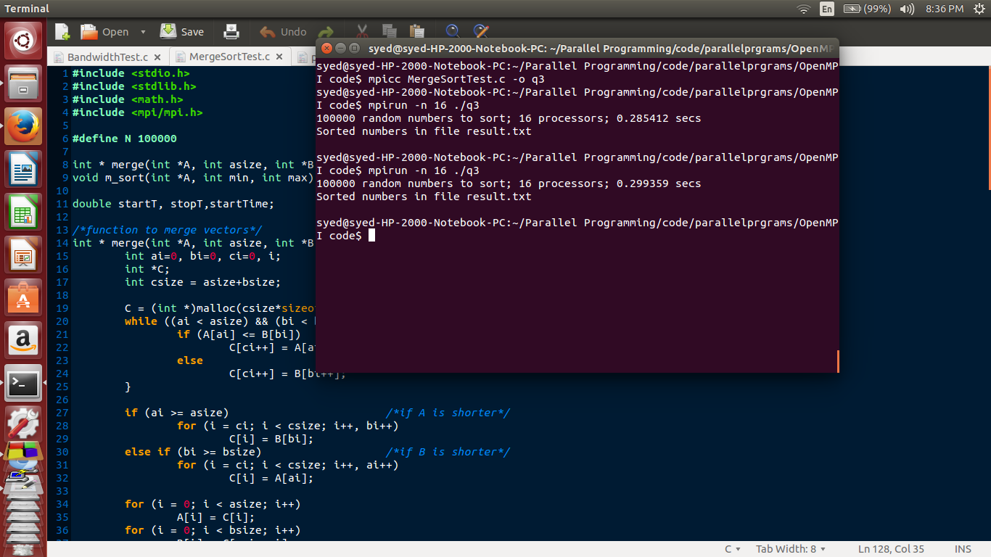
The sorted numbers are in result.txt as below:
